Role Of Optimizer :

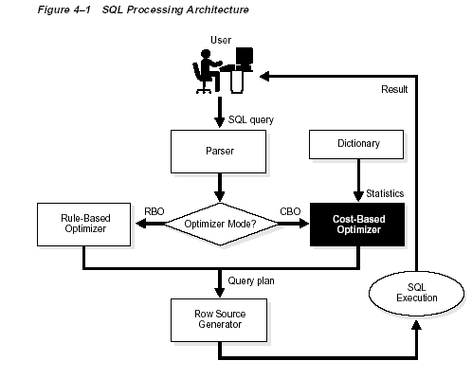

Approaches for Optimizer

- Cost Based Approach
- Rule Based Approach

Cost Based Approach is used when Statistics are maintained in Data Dictionary.Statisics are like :

Table Statistics
– Number of rows
– Number of blocks
– Number of empty blocks
– Average row length

Column Statistics
– Number of distinct values (NDV) in column
– Number of nulls in column
– Data distribution (histogram)

Index Statistics
– Number of leaf blocks
– Levels
– Clustering factor

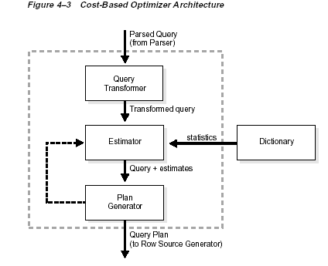
Rule Based Approach is used when there is no statistics available in data dictionary.

Access Path For Rule Based Approach :

Path 1: Single Row by Rowid
Path 2: Single Row by Cluster Join
Path 3: Single Row by Hash Cluster Key with Unique or Primary Key
Path 4: Single Row by Unique or Primary Key
Path 5: Clustered Join
Path 6: Hash Cluster Key
Path 7: Indexed Cluster Key
Path 8: Composite Index
Path 9: Single-Column Indexes
Path 10: Bounded Range Search on Indexed Columns
Path 11: Unbounded Range Search on Indexed Columns
Path 12: Sort-Merge Join
Path 13: MAX or MIN of Indexed Column
Path 14: ORDER BY on Indexed Column
Path 15: Full Table Scan

Role of Optimiser :

- The optimizer first determines whether joining two or more of the tables definitely results in a row source containing at most one row. The optimizer recognizes such situations based on UNIQUE and PRIMARY KEY constraints on the tables. If such a situation exists, the optimizer places these tables first in the join order. The optimizer then optimizes the join of the remaining set of tables.

- If your goal is to improve throughput, then the optimizer is more likely to choose a sort-merge join. If your goal is to improve response time,then the optimizer is more likely to choose a nested loops join.

- If the optimizer uses the cost-based approach for a SQL statement, and if some tables accessed by the statement have no statistics, then the optimizer uses internal information (such as the number of data blocks allocated to these tables) to estimate other statistics for these tables.

- Oracle stores statistics about columns, tables, clusters, indexes, and partitions in the data dictionary for the CBO. You can collect exact or estimated statistics about physical storage characteristics and data distribution in these schema objects.

- Depeneding upon data we can take the decision whether to use index or not. Because for larger data table scan is much better than index scan.For example

Select * from A where a > 1 .

A table has lakh records and column a has value from 1 to lakh.So in this particular example table scan is benefitial than index scan.

- Use the index in like predicate,if like clause begins with no wild character.

- Use rowid to merge or intersect the two indexed Retriever

- Use Max or Min Indexed column. If
  - The query uses the MAX or MIN function to select the maximum or minimum value of either the column of a single-column index or the leading column of a composite index.
  - There are no other expressions in the select list.
  - The statement has no WHERE clause or GROUP BY clause.

To choose among available access paths, the optimizer considers the following factors:

- Selectivity: The selectivity is the percentage of rows in the table that the query selects. A query that selects a small percentage of a table’s rows has good selectivity, while a query that selects a large percentage of rows has poor
selectivity.

To determine the selectivity of a query, the optimizer considers these sources of information:

- The operators used in the WHERE clause.(= operator has good selectivity
than other operators)
– Unique and primary key columns used in the WHERE clause.
– Statistics for the table.

